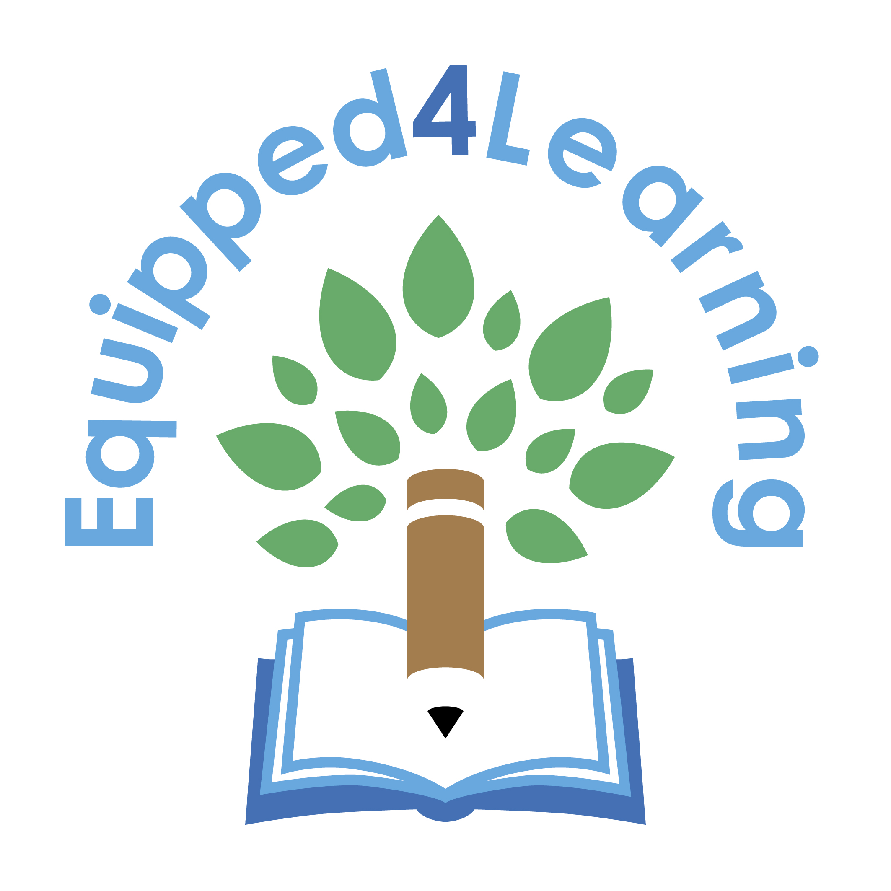
Application Form

Application windows are the months of March, June, and October
Please complete all sections for your application to be considered.
Name of child/young adult:
DOB:
School/College/Uni:
Name of Senco and contact details:
Name of person completing the application:
Relationship to child:
Address:
Tel number:
Email address:
Diagnosis/details of Neurodiverse traits
(to include who diagnosed/ professional seen/date?)

What assessments have been undertaken?

Equipment recommended for education. Please prioritise up to 3 items only, per applicant (this can only include one item of hardware) Please note you may not receive all the equipment you request, depending on funds we have available and individual costs of requested items.
1.
2.
3.

How is the equipment expected to help aid/enable access to education?

Are school or home willing to purchase some of the equipment recommended? Y N Please include details below

Is the report with recommendations attached Y N
If No has been ticked please explain why not?

Do you give permission for the charity to contact the specialist if deemed necessary for further information Y N

Any additional written support of the application?

Please can you briefly, let us know how you heard about our charity?

Signed
Name
Date

